Kubernetes automation using terraform and GKE manifest

Sunday, 26 July, 2020

8:35 AM

Below is my approach to create a GKE on GCP using terraform and k8s manifest files and on the top of Kubernetes there is one app is running used from my docker hub image.

|  |  |
| --- | --- |
| 1 | Terraform IAC (infrastructure as a code) script to create a GKE on GCP |

Machine generated alternative text:
ravi@DESKTOP-QP8SRCg 
ravi@DESKTOP-QP8SRCg 
ravi@DESKTOP-QP8SRCg 
Initializing 
Initializing 
Initializing 
• /mnt/c/Users/user/Desktop/Terraform/gke$ 
• /mnt/c/Users/user/Desktop/Terraform/gke$ 
• /mnt/c/Users/user/Desktop/Terraform/gke$ terraform init 
modules... 
the backend. 
provider plugins... 
Terraform has been successfully initialized! 
Vou may now begin working with Terraform. Try running 
any changes that are required for your infrastructure. 
should now work. 
"terraform plan" to see 
All Terraform commands 
If you ever set or change modules or backend configuration for Terraform, 
rerun this command to reinitialize your working directory. If you forget, other 
commands will detect it and remind you to do so if necessary . 
ravi@DESKTOP-QP8SRCg : /mnt/c/Users/user/Desktop/Terraform/gke$ terraform plan -out 
"devops- plan-GKE . plan" 
var. cluster name 
Enter a value: devops-rocks 
var. proj ect 
Enter a value: challnge-lab-gce 
Refreshing Terraform state in-memory prior to plan 
The refreshed state will be used to calculate this plan, 
persisted to local or remote state storage. 
but will not be 

|  |  |
| --- | --- |
| 2 | The terraform apply output once successful of execution of the IAC script completion |

Machine generated alternative text:
pply complete! Resources: S added, 8 changed, 8 destroyed. 
The state of your infrastructure has been saved to the path 
below. This state is required to modify and destroy your 
infrastructure, so keep it safe. To inspect the complete state 
use the -terraform show' command . 
State path: terraform. tfstate 
ravi@DESKTOP-QP8SRCg : /mnt/ c/ Users/ user / Desktop/Terraform/ gke$ 

|  |  |
| --- | --- |
| 3 | Credentials to your KUBECONFIG (~/.kube/config) so that you can interact with this cluster: |

gcloud container clusters get-credentials <cluster-name> --region us-central1

|  |  |
| --- | --- |
| 4 | Apply the yaml file to deploy the app from docker hub image |

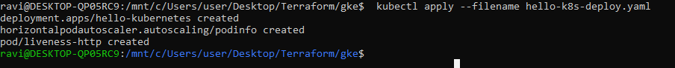

|  |  |
| --- | --- |
| 5 | Deploy the service to create a LB and external ip which will be used to communicate from internet to all pods |

kubectl apply --filename hello-k8s-deploy.yaml

kubectl apply --filename hello-k8s-svc.yaml

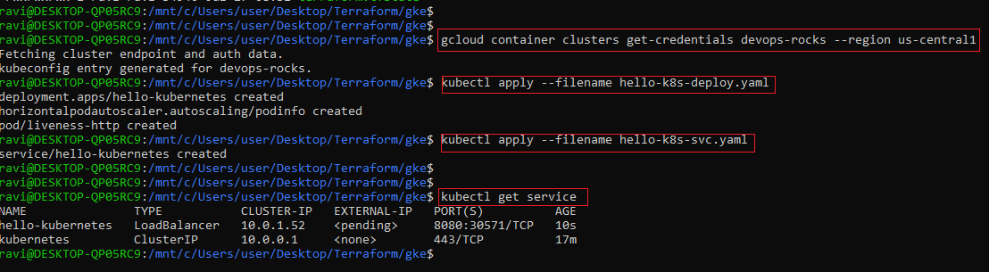

Machine generated alternative text:
navi@DESKTOP-QP8SRCg : /mnt/ c 'Users/ user / Desktop/T err aform/ gke$ 
kubectl get service 
1 el lo- kubernetes 
cubernetes 
TYPE 
LoadBa1ancer 
ClusterIP 
CLUSTER-IP 
18.8.1.52 
18.8.8.1 
EXTERNAL -IP 
35.184. 162.6 
<none> 
PORT(S) 
8888 : 38571 'TCP 
443/ TCP 
AGE 
gmsss 
27m 
navi@DESKTOP-QP8SRCg : /mnt/ c/ Users/ user / Desktop /T err aform/ gke$ 

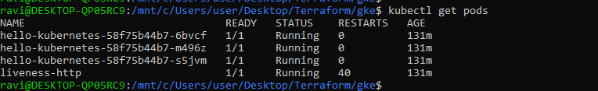

|  |  |
| --- | --- |
| 6 | LB external IP is 35.184.162.6 as its showing |

Machine generated alternative text:
C O O Not secure 35.184.162.6:8080 
Apps Bookmarks Shell Google Certified As... 
GCP 
Cl PGDM 
Cl NICE 
App is running cn part 8080 aver internet 
usinga docker hub image! 
Python NICEWeb NICEOPEDIA - Page... ftp server 
e PIM e ExtraNlCE O 
@ kubernetes 
Hello world! 
pod: 
node: 
hello-kubernetes-58f75b44b7-m496z 
Linux (4.14.138+) 

|  |  |
| --- | --- |
| 7 | High availability test |

Machine generated alternative text:
rav1@DE 
hello-kubernetes 
hello-kubernetes 
hello-kubernetes- 
1 veness- exec 
-58f75b44b7 
-S8f7Sb44b7 
58f75b44b7 
9 /mnt/c/Users/user/Desktop/Terra±orm/gkeS 
READY 
1/1 
1/1 
1/1 
1/1 
- 6bvcf 
-m496z 
-sSjvm 
STATUS 
Running 
Running 
Running 
Running 
RESTARTS 
kubectl get 
AGE 
156m 
156m 
156m 
4m27s 
ravi@DESKTOP-QP8SRCg : /mnt/ c 'Users/ user / Desktop/T err aform/ gke$ 
ravi@DESKTOP-QP8SRCg : /mnt/ c/ Users/user / Desktop/Terraform/ gke$ 
ravi@DESKTOP-QP8SRCg : /mnt/ c/ Users/user / Desktop/Terraform/ gke$ 
kubectl delete pod hello-kubernetes-S8f7Sb44b7-sSjvm 
pod "hello-kubernetes-S8f7Sb44b7-sSjvm" deleted 
ravi@DESKTOP-QP8SRCg : /mnt/ c/ Users/user / Desktop/Terraform/ gke$ 
ravi@DESKTOP-QP8SRCg : /mnt/ c/ Users/user / Desktop/Terraform/ gke$ 
ravi@DESKTOP-QP8SRCg : /mnt/ c/ Users/user / Desktop/Terraform/ gke$ 
kubectl get pods 
READY STATUS 
RESTARTS AGE 
hello- kubernetes - 58f7Sb44b7 - 6bvcf 
hello- kubernetes - S8f7Sb44b7 -m496z 
hel lo- kubernetes- 58f7Sb44b7- rnndv 
11 veness- exec 
1/1 
1/1 
1/1 
1/1 
Running 
Running 
Running 
Running 3 
156m 
156m 
4m; Is 
ravi@DESKTOP-QP8SRCg : /mnt/ c 'Users/ user / Desktop/T err aform/ gke$ 
ravi@DESKTOP-QP8SRCg : /mnt/ c/ Users/ user / Desktop/T err aform/ gke$ 

|  |  |
| --- | --- |
| 8 | Logging can be checked from GCP Stackdriver logging (log viewer) |

Machine generated alternative text:
Google Cloud Platform 
Operations 
Logging 
Logs Viewer 
Logs Dashboard 
Logs-based Metrics 
Logs Router 
Logs Ingestion 
Challnge-Lab-GCE 
CLASSIC 
Search products and resources 
CREATE METRIC 
CREATE SINK 
a SAVE SEARCH 
O New features are available in the Logs Viewer Preview To switch between the preview and classic interfaces, use the drop-down in the top action bar. View Blog 
Dismiss 
SHOW LIBRARY 
L aunch preview 
Filter by or text sesrcf7 
GKE cluster operations, devops-rocks, 
cloudaudit_googleapis.m 
Into 
@ Last 24 hours 
Showing logs from 26 Jul 2020, to now (HKT) 
Jump to now 
Load older logs 
Download logs View options 
: "type . googleapis . com/google . cloud . audit . AuditLog" , "authenticationlnfo " : { " prim 
2020-07-27 HKT 
2020-07-27 HKT 
Rubernetes 
Rubernetes 
Engine API 
Engine API 
CreateCIuster 
CreateCIuster 
us-central I: devops-rocks {"@type" : . com/google.cloud.audit . AuditLog" , "status" "container . googleapis "nethodNane": "google . cow 
us-central I: devops-rocks tf-svc@challnge-lab-gce . iam.gsemwiceaccount . com 
No newer entries found matching current filter. Load newer logs 